Analogy Reasoning Evaluation details

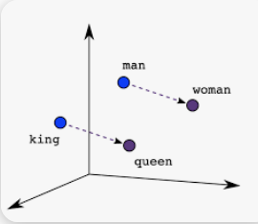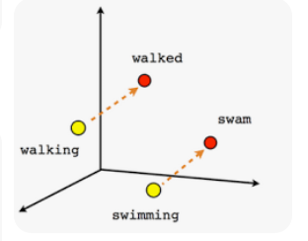
Vec(king) – vec(queen) = vec(man)-vec(woman) Vec(walking) – vec(walked) = vec(man)-vec(woman)

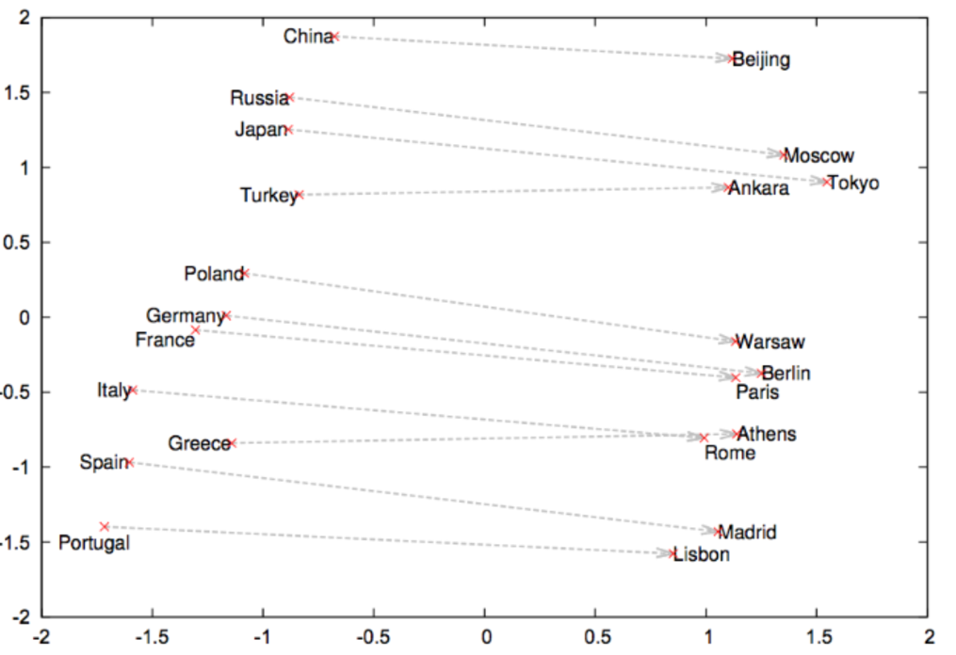
Vec(china) – vec(beijing) = vec(russia)-vec(moscow) [Note: this relation is usually not exact]

In analogy reasoning evaluation, we first compute the prediction vector:
Vec_pred = Vec(china) – vec(beijing) + vec(moscow)
The in the list of words, we search the word-embedding-vectors to find the closest word.
If the searched word is “moscow”, this analogy for these word grouping is correct. Otherwise, it’s false..

